- Network Testing Tools Theory

Q.1 Use the ping command to test connectivity from your computer to www.youtube.com and note the average response time?

Answer

- Ping Test to YouTube
I used the ping command to test connectivity to www.youtube.com.
ping www.youtube.com
- Average Response Time: 43 ms
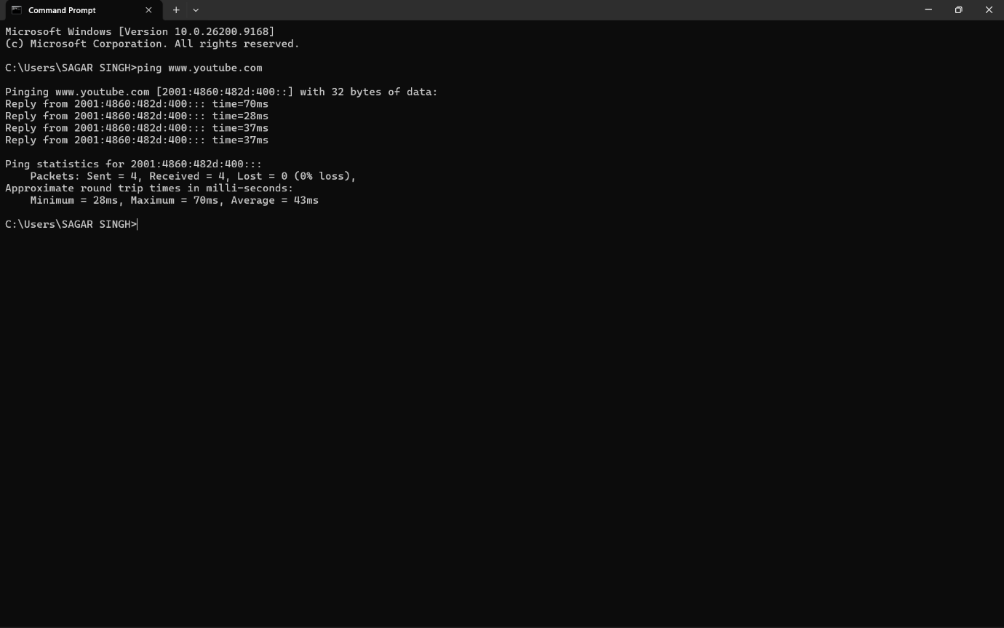
Packet Loss: 0%

- Result:
The ping test was successful, and the average response time to YouTube was 43 ms.

Q.2 Run the traceroute (tracert on Windows) command to www.flipkart.com and list all the intermediate hops shown in the output.<br><br><em><strong>Hint:</strong> Each hop represents a network device your data passes through to reach the destination.</em>?

Answer

- Traceroute to Flipkart
I used the following command to trace the path to www.flipkart.com:
tracert www.flipkart.com
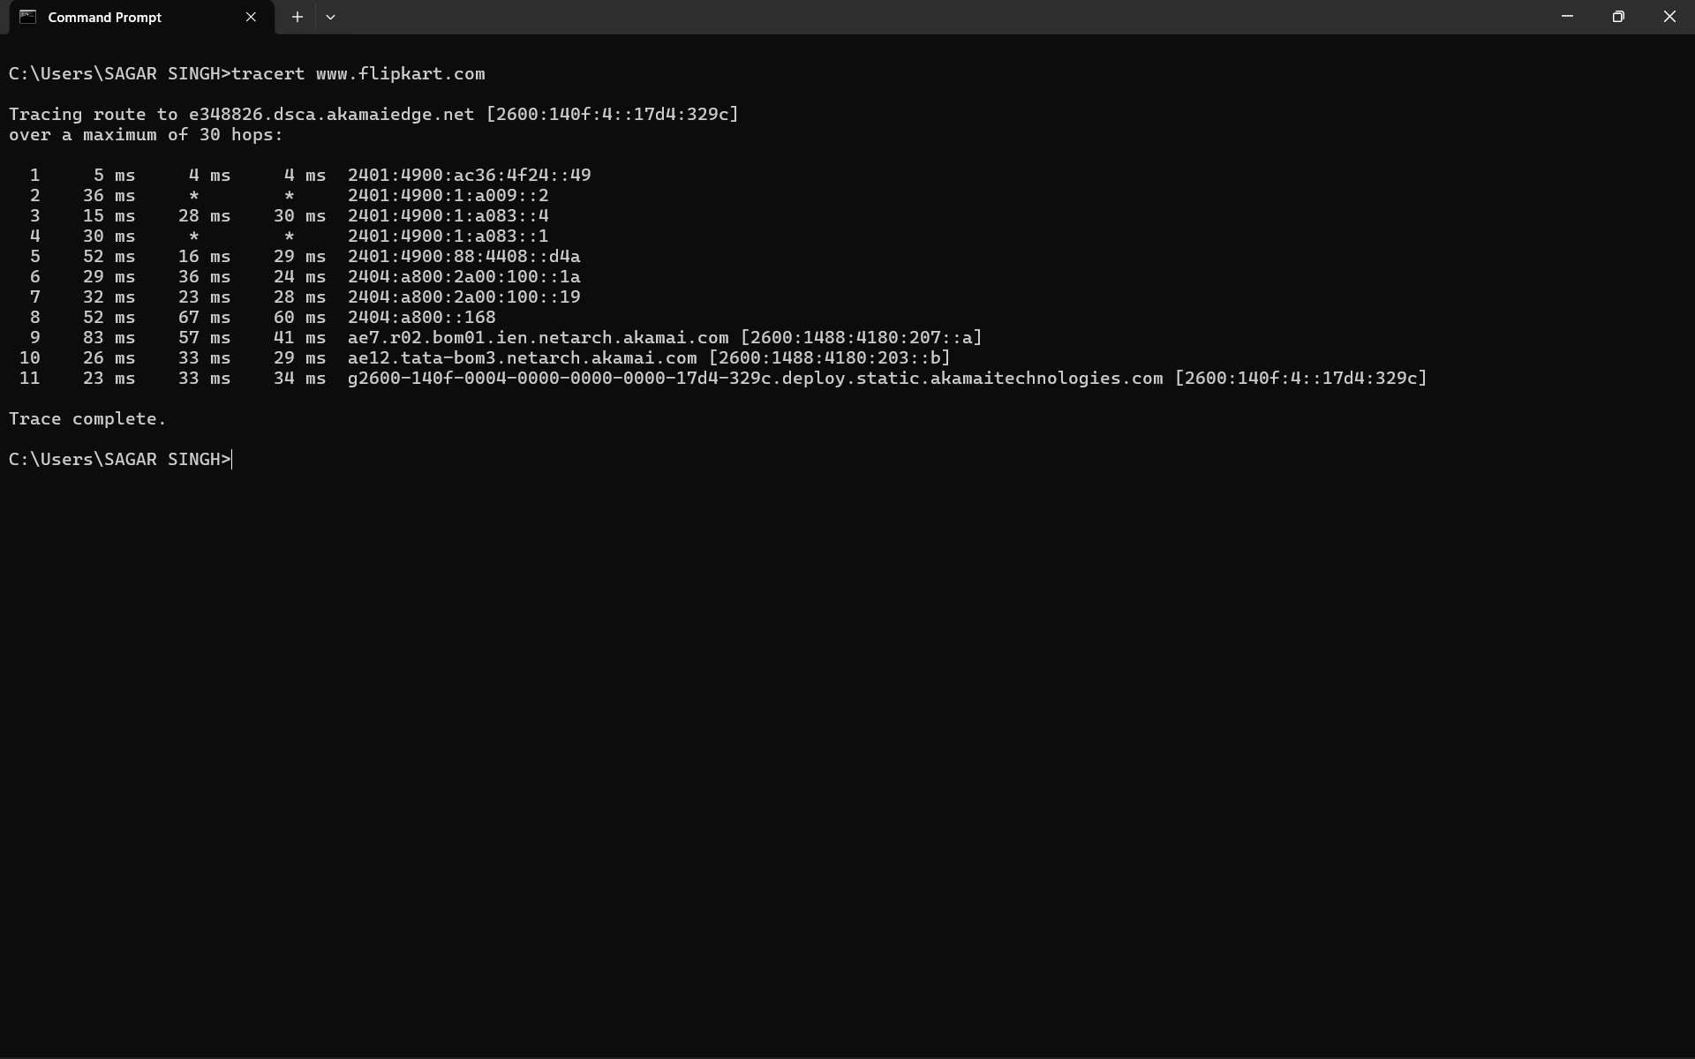
- Result:
The traceroute completed successfully and showed that the data passed through multiple network hops before reaching Flipkart’s destination server.

Q.3 Use the nslookup tool to find the IP address of www.zomato.com and record the result?

Answer

- NSLookup for Zomato
I used the nslookup command to find the IP address of www.zomato.com.
nslookup www.zomato.com
- The result returned the following IP addresses:
- 23.55.244.120
- 23.55.244.115
- 23.55.244.137
- 23.55.244.138
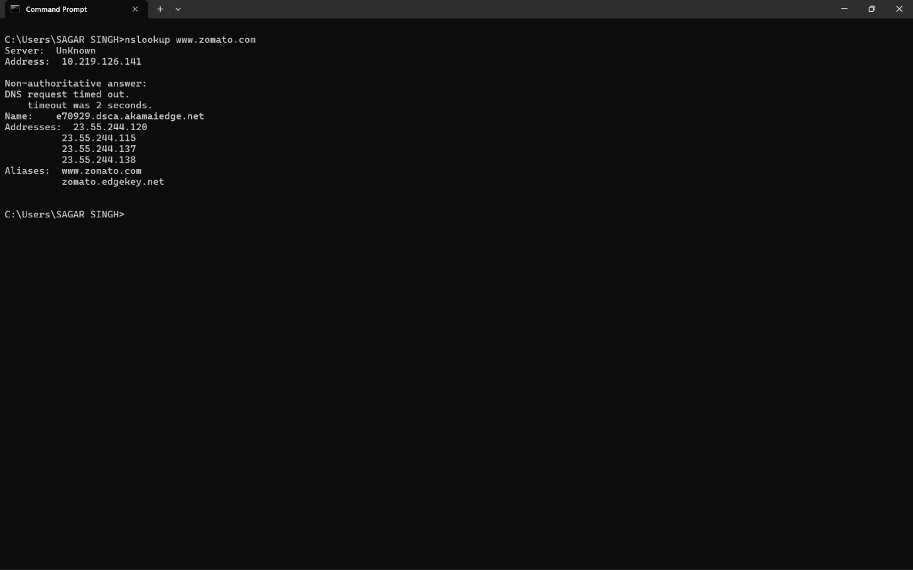
- Result:
The nslookup command successfully resolved www.zomato.com to multiple IP addresses.

Q.4 Test connectivity to another device on your local network (such as your friend's laptop or your phone) using the ping command and describe what happens if the device is offline?

Answer

- Testing Connectivity to Another Local Device
I tested connectivity to another device on my local network using the following command:
ping 10.219.126.174
- When the device was online, the ping was successful and showed 0% packet loss.
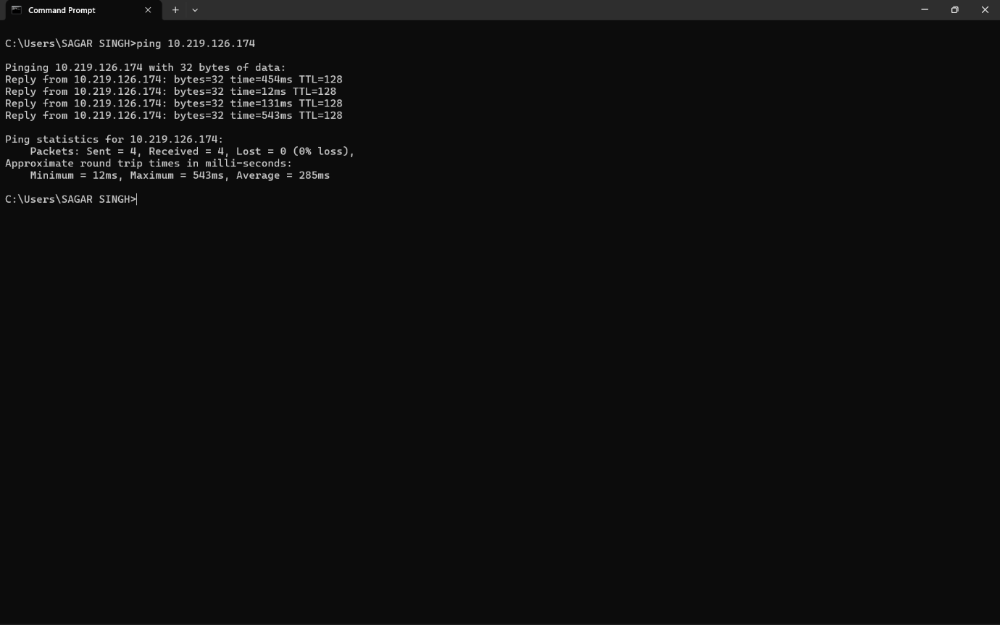
- Then I disconnected the device from the network and ran the same command again.
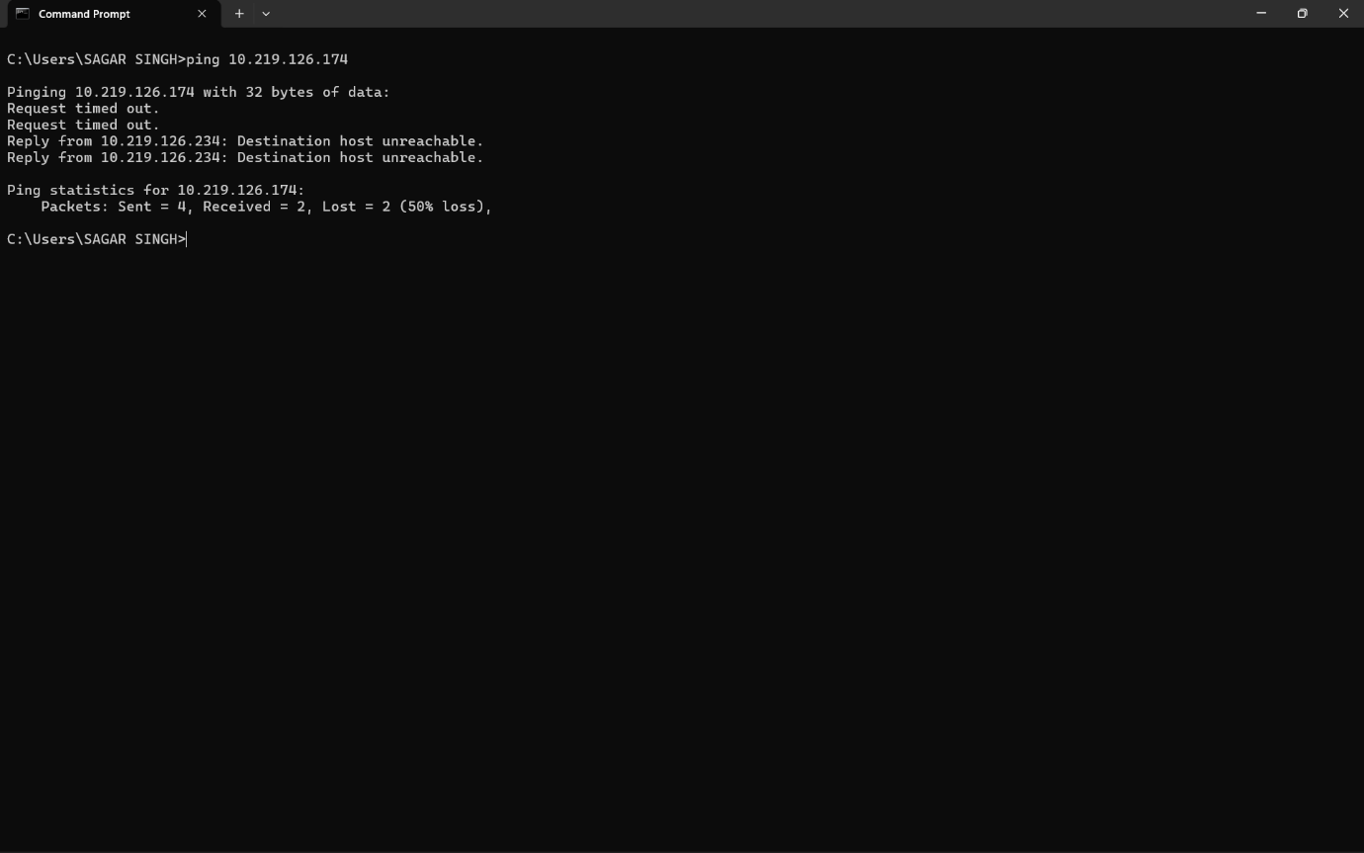
- Result:
When the device was offline, the ping showed Request timed out and Destination host unreachable. This means the device was no longer reachable on the local network.

Q.5 Create a short report (5-7 lines) summarizing which tool (ping, traceroute, nslookup) is most useful for diagnosing each of these problems: (a) Website not loading, (b) Slow connection, (c) Suspecting DNS issues.<br><br><em><strong>Constraint:</strong> Give a specific example for each tool based on your own test results above.</em>?

Answer

- Short Report on Network Diagnostic Tools

- For a website not loading, I would first use ping to check whether the website or server is reachable. In my test, ping www.youtube.com worked successfully with an average response time of 43 ms and 0% packet loss.
- For a slow connection, I would use tracert because it shows the path and delay at each network hop. In my Flipkart test, the route completed in 11 hops, which helps identify where delay may occur.
- For DNS-related problems, I would use nslookup because it checks whether a domain name can be converted into an IP address. In my test, nslookup www.zomato.com successfully returned multiple IP addresses.
- Therefore, ping is best for basic connectivity, tracert is useful for finding slow network paths, and nslookup is best for checking DNS problems.

